## Library Module – Static Library

1. Create 3 files as below. Let cal_utility.c, .h files be part of the library
   * libapplication.c – will contain main() and will invoke functions in cal_utility.c

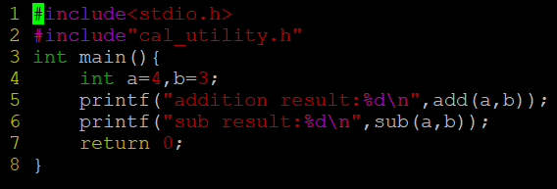

* + cal_utility.c – will contain atleast 2 or more functions [ You may add definitions of the functions in this file ]

* + cal_utility.h – will contain the extern declarations/prototypes of the functions in cal_utility.c

1. Refer the steps for static library based application and create a static library application using above set of files.

Ans: 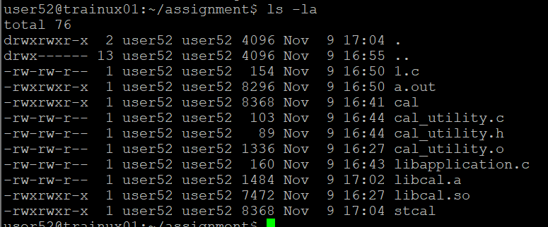

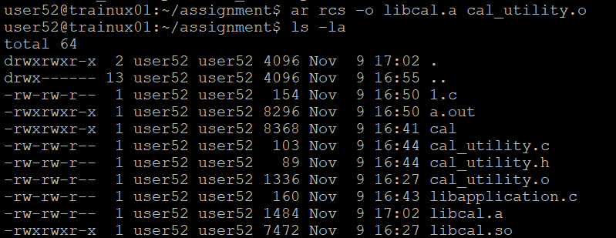

1. Execute the application created in step #2

Ans: gcc libapplication.c -L./ -lcal -o stcal

./stacl

